Chapter 14, Problem 97.

The crossover circuit in Fig. 14.109 is a highpass filter that is connected to a tweeter. Determine the transfer function H(ω) = V_{o}(ω)/V_{i}(ω).

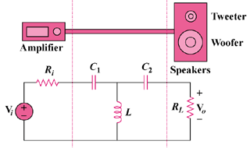

Figure 14.109
For Prob. 14.97.

